Broken Glass Slippers
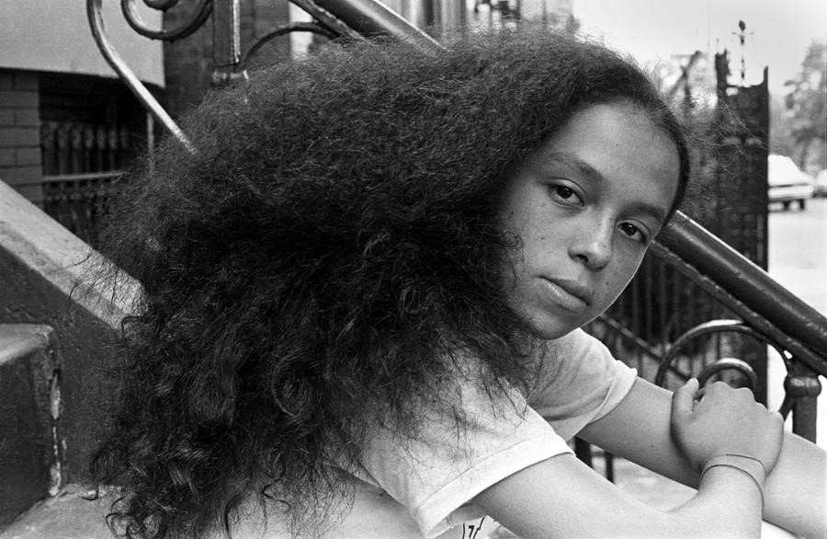
Set in the South Bronx, during the midst of the crack epidemic, Abraham Rodriguez’ Jaguar explores a mother daughter relationship and the social issues and injustices that plague impoverished communities of color. Through Iris and her mother, Angie, Rodriguez looks at the female perspective of street life, the cycle of poverty, addiction and sex for survival. While both mother and daughter place their self-worth in their sexuality and desire the false security of unconditional love, the focus is on Iris’ demise.
Rodriguez understands noir as a genre; Jaguar and the South Bronx in the 1980s are the epitome of it. Once a prosperous suburb and “boomtown with the influx of hundreds and thousands of German, Irish, Italian and Jewish immigrants...by the 1970s, the Bronx [is] burning” (Jonnes). Devastated by poverty, drugs and arson and populated by Puerto Rican and African American working-class citizens living in ruin and rubble. By the 1980s, the South Bronx and many of its residents depict noir: crime ridden, notably dark, brooding, cynical, complex and pessimistic (Harmon and Holman 352).
However, it is from this despair that hip hop is born. Grandmaster Flash and the Furious Five’s The Message paints a hopeless picture of urban poverty and the desire to get out from under it. It reveals the secret to maintaining their sanity and surviving in “a jungle.” And it's a warning to those in and outside of the ghetto: “don’t push me, cause I’m close to the edge.” The lyrics are so poignant, it was “selected by the New York Times as ‘the most powerful pop single of 1982.”
Broken glass everywhere
People pissing on the stairs, you know they just don't care
I can't take the smell, can't take the noise
Got no money to move out, I guess I got no choice
Rats in the front room, roaches in the back
Junkies in the alley with a baseball bat
I tried to get away, but I couldn't get far
'Cause a man with a tow truck repossessed my car
These are the images that come to mind at the opening of Jaguar. The lyrics embrace the noir aspects of cynicism, pessimism and decay in the South Bronx.
On these streets of “broken glass,” Iris spends her school days sitting on the stoop of her building, tempting men in cars with a wave or a stare, waiting for someone or something “to happen.” Iris may dress up to be a “different girl every day,” however she is nothing more than “a lost girl” desperate to be found (Rodriguez 136).
With a man on the loose, “gutting hookers like fish,” (Rodriguez 136) Iris knows that with each car she steps into, she’s inviting the possibility of death and danger. It is the risk she’s willing to take for her hood knight in bullet proof armor.
On South Bronx streets, life is worth maybe a subway token. Cops don’t take subways. If the hookers were white maybe it would be more of a story, more tragic TV reports. But South Bronx killing zone is an everyday thing, and so one more hooker body appearing near Hunt’s Point is not really a crime, just seen like waste disposal. Like a man dumping his trash. (Rodriguez 137)
While her body is a commodity, Iris understands her life is essentially worthless. If murdered, her story would not make the headlines, the police would not seek justice. Her life as a poor
Puerto Rican teenager and sex worker doesn’t deserve it.
Raised by a teenage mother, Angie, who turned tricks in the bedroom while Iris watched cartoons in the living room. Her mother had sex with men for money and her “father figure” was a pimp named, Pacheco. Iris is a product of her environment.
[1st draft UNFINISHED]
WORKS CITED
Adler, Bill. “The South Bronx Was Getting a Bad Rap Until a Club Called Disco Fever Came Along.” May 16, 1983 https://people.com/archive/the-south-bronx-was-getting-a-bad-rap-until-a-club-called-dis co-fever-came-along-vol-19-no-19/
Flores, Ricky. “Hip Hop Photos” 9 March 2017, https://www.dazeddigital.com/photography/article/35056/1/ricky-flores-bronx-burning-h ip-hop-photos
GrandMaster Flash and the Furious Five. Lyrics to “The Message.” Genius, 2011, https://genius.com/Grandmaster-flash-and-the-furious-five-the-message-lyrics Harmon, William, and Hugh Holman. A Handbook to Literature. 10th ed., Pearson Education,
1996.
Rodriguez, Abraham. “Jaguar.” Bronx Noir, edited by S.J. Rozan,
Akashic Books, 2007, pp 136 -149
Rosen, Miss. “How hip hop rose from the ashes of the Bronx.” 9 March 2017, https://www.dazeddigital.com/photography/article/35056/1/ricky-flores-bronx-burning-h ip-hop-photos

